📝 CODEALPHA CAD DESIGN INTERNSHIP
PROJECT REPORT: TASK 1
Design and Modeling of a 3D Flanged Bearing Housing
- Intern Name: Mitushi Jain
- Domain: CAD Design
- Submission Date: June 11, 2026
- Software Tool: Autodesk AutoCAD 2026 (Educational Version)
1. Introduction
The objective of this task was to create a precise 3D solid parametric model of a Flanged Bearing Housing using Autodesk AutoCAD. A flanged bearing housing is a critical mechanical component widely used in industrial machinery to support rotating shafts, minimize friction, and securely anchor assemblies to flat structural surfaces via mounting bolt configurations.
This project focused on establishing solid geometric primitives, manipulating coordinate tracking systems, executing polar arrays, and utilizing Boolean operations to achieve a manufacturing-ready design.
2. Technical Specifications & Dimensions
The model was constructed based on standard engineering dimensions to ensure structural integrity and realistic fitment:
Feature Component | Parameter | Metric Value
Lower Base Flange | Outer Diameter / Thickness | 100 mm / 15 mm
Middle Stepped Ring | Outer Diameter / Height | 60 mm / 15 mm
Upper Pillar Cylinder | Outer Diameter / Height | 45 mm / 60 mm
Central Shaft Bore | Inner Diameter (Hollow) | 35 mm (Radius: 17.5 mm)
Pitch Circle Diameter (PCD) | Bolt Circle Layout Diameter | 80 mm (Radius: 40 mm)
Mounting Fasteners | 4x Bolt Hole Openings | 8 mm Diameter (Radius: 4 mm)
3. Methodology & 3D Modeling Process
Phase 1: Base Geometry Generation
- Solid Primitives Creation: Three separate cylinder primitive shapes were modeled coaxially along the absolute $Z$-axis center point $(0,0,0)$ to build the flanged structure's core profile.
- Solid Union: The separate cylinders were merged into a single, seamless 3D solid object using the UNION command to establish structural consistency.
Phase 2: Tooling Layout & Array Configuration
- Coordinate System Alignment: The World Coordinate System (UCS W) was verified to align geometric projections accurately.
- Layout Pathing: A geometric circular reference pathway was projected at a radius of 40 mm.
- Polar Array Distribution: A cutting tool cylinder of 4 mm radius was instantiated at position $(0,40,0)$ and systematically duplicated via the ARRAYPOLAR command. The item count parameters were explicitly modified to distribute exactly four entities spaced evenly across a full 360-degree layout.
Phase 3: Boolean Material Removal
- Array Dissisociation: The associative array grouping was unpacked using the EXPLODE command to yield four separate 3D solid cutting components.
- Bore and Clearance Machining: The SUBTRACT operation was executed. The main flanged body was chosen as the object to retain, while the 17.5 mm radius central shaft cylinder and the four outer arrayed pins were designated as the material subtraction bodies.
4. Final Visual Output
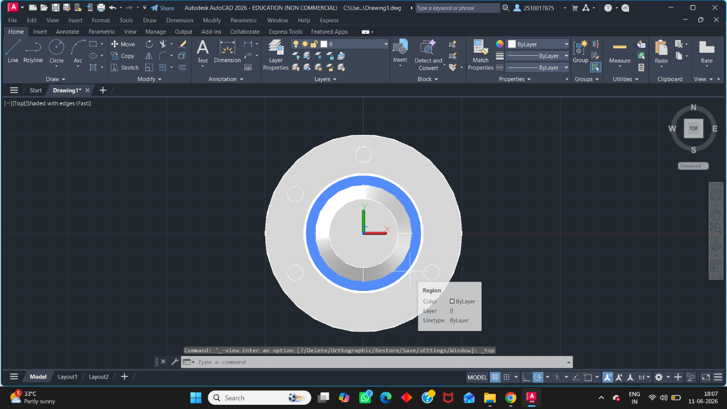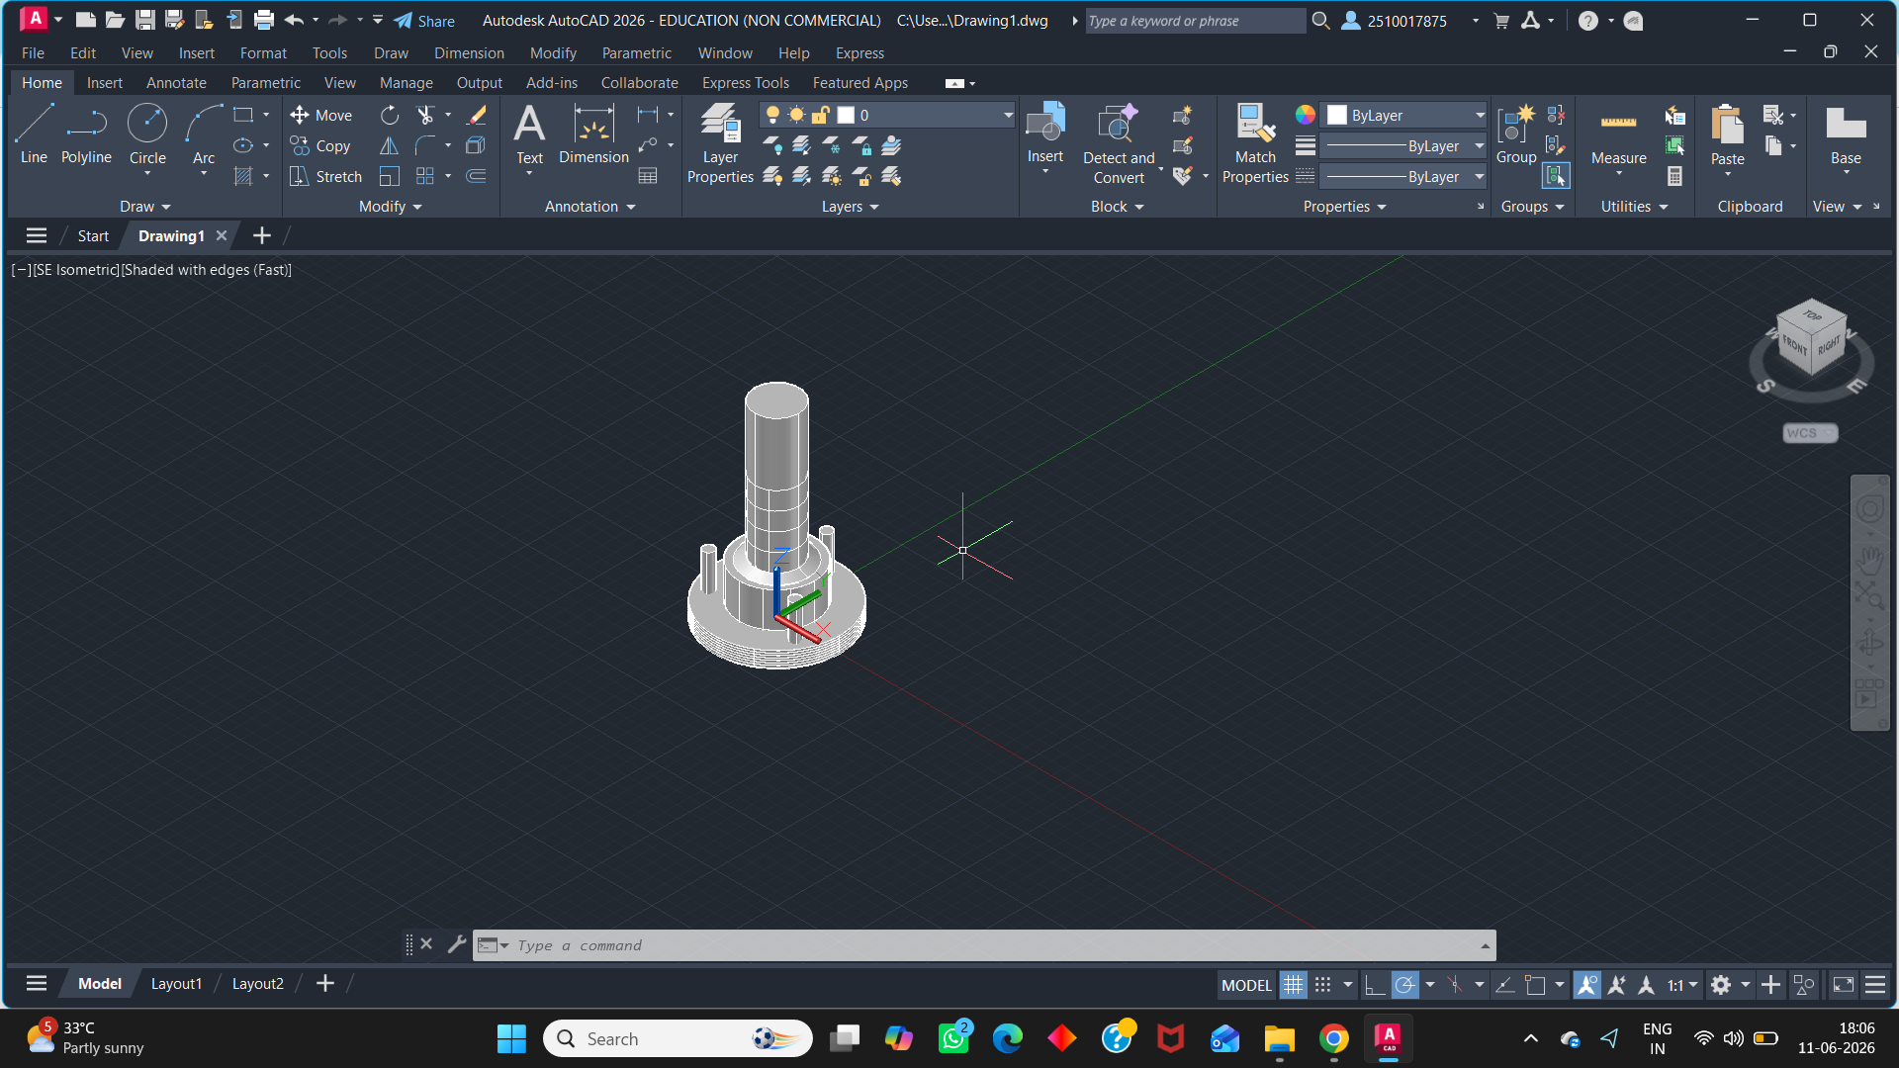

5. Conclusion
Task 1 has been successfully completed in full compliance with the engineering assignment criteria. The final 3D model exhibits a completely continuous internal hollow bore, correct mechanical step-downs, and clean, uniform clearance holes through the mounting flange.
The resulting digital file demonstrates an understanding of 3D Boolean workspace operations, absolute coordinate positioning workflows, and rigorous solid-modeling fundamentals essential for mechanical design pipelines.

